Type of Attack | Components it affects
Spectre v1 (bounds check bypass)  (Trains the branch predictor to always take a branch, then executes a branch speculatively with an illegal address that accesses a secret key. The secret key get used as index for an array which gets read, loading the array element into the cache. By using the Flush and Reload method the attacker can find out which element was loaded in the cache, and therefore discover the key). | Cache, Branch Predictor
Spectre v2 (branch target injection)  (Trains the BTB to predict the address of a function that reads a valid memory address. During the attack the attacker calls an indirect jump to a different function’s address while accessing an illegal memory address. Because of the training, the BTB executes the illegal instruction speculatively and the attacker accesses the secret key which gets used as index for an array. The array element gets loaded into the cache and by using the Flush and Reload method, the attacker can discover the key.) | Cache, Branch Target Buffer
Spectre v5 (return stack buffer)  (Changes the return address from the stack frame, so that the RSB misspeculates to a function that reads a secret key from the memory into an array as an index. The attacker then reads the array element which gets loaded into the cache. By using the Flush and Reload method the attacker can find out the index of the array element which was loaded, and therefore the secret key.) | Cache, Return Stack Buffer
Flush and Reload  (flushes cache lines, let’s victim execute then attacker measures cache access time to find out which cache lines the victim has accessed – requires shared cache between attacker and victim) | Cache
Prime and Probe  (Primes cache sets with arbitrary data, then let’s the victim program run. Attacker accesses the cache sets again, and if the access time is high it means the victim has accessed those sets and filled them with its own information. Therefore the attacker can find out which sets the victim has accessed.) | Cache
Evict and Reload  (attacker forces the cache to evict its data by accessing already loaded cache lines. Victim executes and loads data into cache . Attacker then measures cache access time to find out which cache lines the victim used) | Cache
Evict and Time  (Attacker times the victim program, then evicts some cache lines and times the victim program again. By measuring the difference in runtime the attacker can find out which cache lines the victim uses.) | Cache
Flush and Flush  (Attacker flushes cache lines, then lets victim program run. Attacker then flushes the cache lines again and measures the difference between the flush executions to find out if the cache lines were accessed during the victim execution.) | Cache

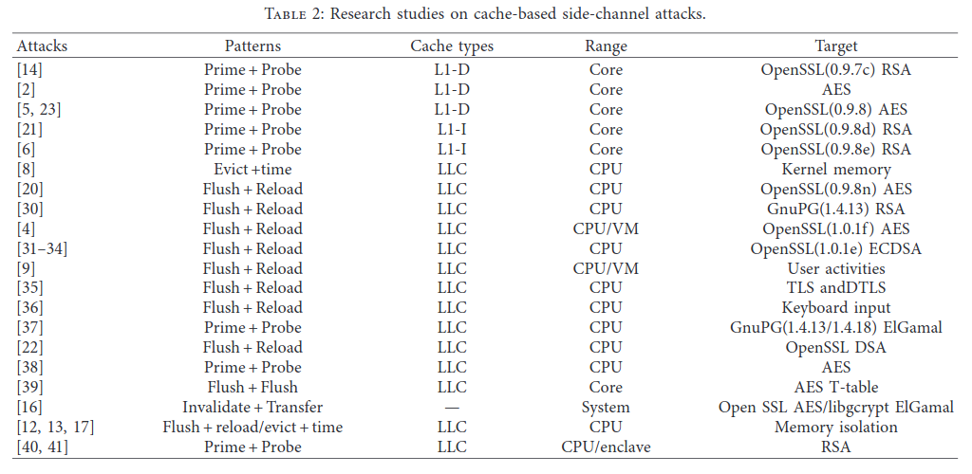
Table taken from Survey of CPU Cache-Based Side-Channel Attacks: Systematic Analysis, Security Models, and Countermeasures

